Support and Maintenance of the TrustyBank application

Diagram of the class structure of the application:

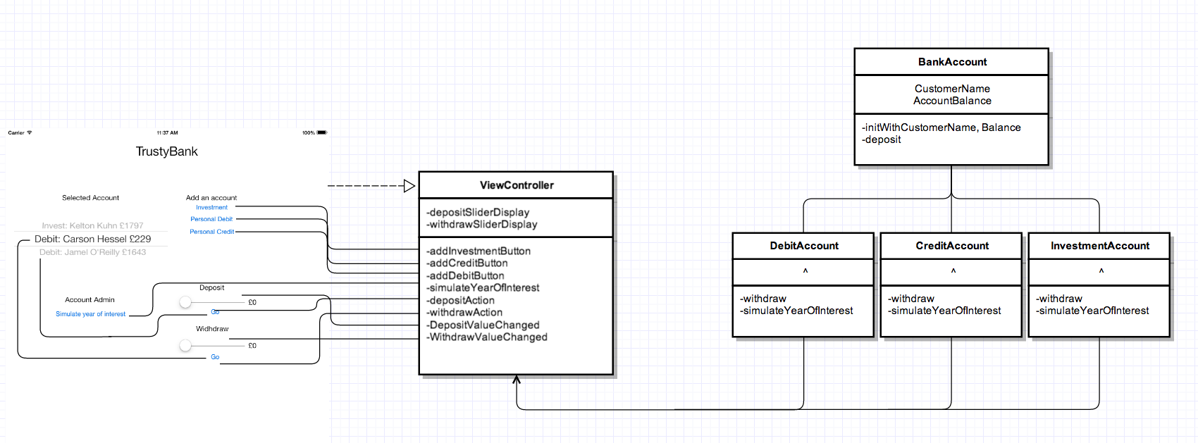

Class explanation

|  |  |  |  |
| --- | --- | --- | --- |
| Class | Method | Use | Returns |
| ViewController |  |  |  |
| addInvestmentButton | Creates a new account of the appropriate class and stores the object of it in the pickerView, then reloads the pickerview’s delegate to load this new account. | void |
| addCreditButton |
| addDebitButton |
| simulateYearOfInterest | Calls the method - simulateYearOfInterest from all the accounts held in the pickerView array | void |
| depositAction | Retrieves the selected account from the pickerView and then calls the deposit/withdraw method with the data extracted from the appropriate slider. | void |
| withdrawAction |
| DepositValueChanged | Called when the sliders are changed, this stores the value and sets the label next to the sliders to their value. | void |
| WithdrawValueChanged |
| BankAccount | initWithCustomerName,Balance | The initialisation method for the Bank accounts which takes in the name and balance from the VC and then calls the superclass [NSObject init] – returns the ID to the VC for the pickerView | Object id |
| description | Creates a readable description for the PickerView which contains the CustomerName and account balance | NSString |
| deposit | All accounts share the same deposit method – so it’s in the superclass. Called with a double parameter to add to the ‘AccountBalance’ | void |
| DebitAccount/  CreditAccont/  InvestmentAcc. | withdraw | Withdraw method which applies the individual account behaviours to the withdrawal process. – Checks for the minimum balance and performs applicable transaction fees then removes the balance from the superclass double ‘AccountBalance’ | void |
| simulateInterestYear | Simulates the interest of a year depending on the account type then adds this to the superclass double ‘AccountBalance’ | void |
| description | Adds the account type to the name of the superclass’s Description and returns an NSString | NSString |